# INN570 2013 Week 3 Prac Exercises

# Input Method Editors

# In this exercise, we will continue with the work from last week. Firstly, we will add code to make the application to open and save files. Then, we will introduce input method editors (IME) to input text in different languages.

# Open and Save files

Starting from the provided existing code *BBookWk2*, we will provide simple event handlers for the *File ->Open* and *File ->Save* menu choices. Double clicking on the menu item *Open* and *Save* in design view, we open the corresponding code in the code view, i.e., methods *openToolStripMenuItem_Click*,and *saveToolStripMenuItem_Click*.

We now insert the relevant code to the File Open method:

private void openToolStripMenuItem_Click(object sender, EventArgs e)

{

OpenDialog.Reset();

OpenDialog.InitialDirectory = Directory.GetCurrentDirectory();

OpenDialog.RestoreDirectory = false;

OpenDialog.Filter = "Text files (*.txt)|*.txt|All files (*.*)|*.*";

if (OpenDialog.ShowDialog() == DialogResult.OK)

{

StreamReader MyStream = new StreamReader(OpenDialog.FileName);

BBookGrid.DataSource = null;

m_BBookTable.Clear(); //Clear the existing table

BBookGrid.DataSource = m_BBookTable;

try

{

while (true)

{

String MyLine = MyStream.ReadLine();

if (MyLine == null)

{

break;

}

else if (MyLine.Length != 0)

{

String[] fields = MyLine.Split(Separator.ToCharArray());

if (fields.GetLength(0) == 2)

{

m_BBookTable.Rows.Add(m_BBookTable.NewRow());

m_BBookTable.Rows[m_BBookTable.Rows.Count - 1][NameCol] =

fields[0].Trim();

m_BBookTable.Rows[m_BBookTable.Rows.Count - 1][DateCol] =

fields[1].Trim();

}

}

}

}

catch (Exception ex)

{

MessageBox.Show("Fatal Error" + ex.ToString());

Application.Exit();

}

}

}

And then similar code to the Save method:

private void saveToolStripMenuItem_Click(object sender, EventArgs e)

{

SaveDialog.Reset();

SaveDialog.InitialDirectory = Directory.GetCurrentDirectory();

SaveDialog.RestoreDirectory = false;

SaveDialog.Filter =

"Text files (*.txt)|*.txt|All files (*.*)|*.*";

if (SaveDialog.ShowDialog() == DialogResult.OK)

{

try

{

StreamWriter MyStream = new

StreamWriter(SaveDialog.FileName);

foreach (DataRow MyRow in m_BBookTable.Rows)

{

MyStream.WriteLine(MyRow[NameCol].ToString() +

Separator + MyRow[DateCol].ToString());

}

MyStream.Flush();

MyStream.Close();

}

catch (Exception ex)

{

MessageBox.Show("Fatal Error\n" + ex.ToString());

Application.Exit();

}

}

}

At present, these are of limited value. But we will use them again later. We now move on to use Input Method Editor to input text in different languages onto the Birthday form.

# Input Method Editor

In this part of the exercise, we need to add IMEs for input in different languages. We will use Chinese as an example.

* **Add Chinese IMEs to your keyboard input**

Instructions for this prac vary between Windows 7 and XP. We will use Windows 7 in this unit. In Windows 7, open Control Panel, select ‘Region and Language’, then select ‘Keyboards and Languages’ and click on the ‘Change Keyboard’ button. From the resulting dialogue, click on ‘Add’ as shown below:

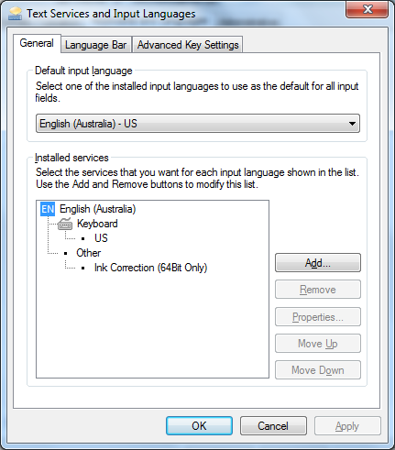

A tree list of available languages is then available. Select ‘Chinese (Simplified, PRC)’, and then expand the tree to show the available simplified Chinese IMEs (as seen in the screenshot below). From the list, you can choose the IMEs that you want, for example, choose ‘Chinese (Simplified)-QuanPin’, then click on ‘Ok’.

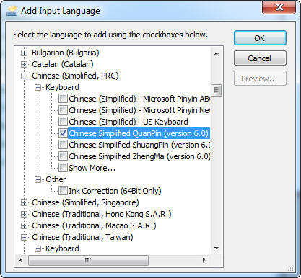

Once installed, the IMEs can be seen in Language Bar – go to the task bar at bottom right.

* **Enter the Chinese Names in Birthday Book**

First you must use the language bar to select the input to be Chinese – once this is selected, you should have something similar to the following one:



While the Chinese Input Method was installed, we can use it in the Birthday Book to enter names in Chinese.

* Run the Birthday Book application. Make sure you have chosen the Chinese input method in the language bar. Click on an available slot in the column *Name*, as showed in the following screenshot, enter ‘*shan*’ and choose ‘山’, then ‘*mu*’ and choose ‘姆’. 山姆 is a Chinese translation of English name *Sam*. Then enter a date whatever that you want in the column *Birthday*. Before this, you should change the input method to English.

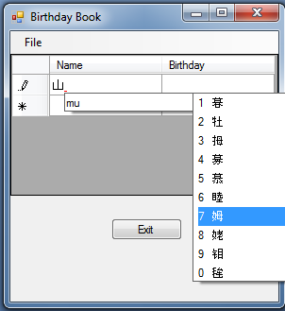

* You can add more names and dates using the same method, for example, ‘*zhan*’ for ‘詹’, ‘*mu*’ for ‘姆’, ‘*shi*’ for ‘士’. 詹姆士 is a Chinese translation of English name *James*.
* Save the file in your current folder, and name it, e.g., “Chinese.txt”. Before this, you should change the input method to English.
* Use Windows File Explorer to open “Chinese.txt”, the txt file should look like the following:

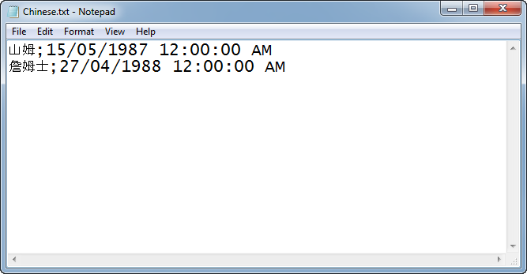

* Then try to save the txt file by choosing ASCII encoding. From File->Save as->Encoding, choose “ANSI”.

Ignore the following warning message.

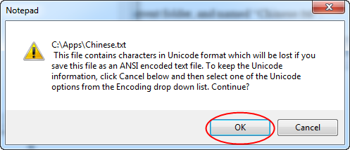

Reopen “Chinese.txt”, you will find that the Chinese names would have been replaced with question marks(??). If you use Birthday Book to open “Chinese.txt”, the Chinese names would be displayed as question marks as shown below.

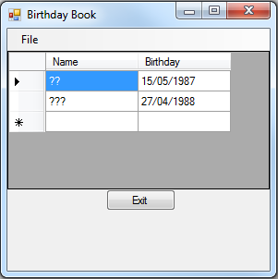

Next week, we will continue working on this application and observe the effect of different encodings and also try some decoding methods in .NET.